PROPOSED CHANGES TO THE FURNITURE AND FURNISHINGS (FIRE) (SAFETY) REGULATIONS 1988

Summary of the difference between the two match tests
The current match test ensures the ignitability and protectiveness of cover fabrics in test conditions but not necessarily in finished products. Because it assumes protection from flame spread is guaranteed, it does not require other materials in products, beneath the covers, to be flame-resistant.
The new test replicates finished products. It also ensures overall protectiveness by requiring all materials within 40mm of the outer cover in a product to be non-ignitable to a match flame.
Intertek’s research work in developing the new test, which has been confirmed by FIRA, also now shows that the current test does not always provide non-ignitable cover fabrics in finished products. For that reason, it also means cover fabrics don’t always provide the protection for other materials that has always been believed to be the case.
Further Detail
The current test
The current match test is designed to replicate a match/small flame igniting cover fabric on upholstered furniture. The test requires a flame to be held against fabric for 20 seconds; after it’s removed the flame must go out within two minutes.
The current test method requires cover fabric to be placed tightly against test foam that is flammable - the kind that was used in furniture before the Regulations were introduced in 1988.
This test rig was intended to test both the ignitability of the cover fabric and its ability to protect what’s beneath it.
There are different views on why the current test does not require test foam that was of the kind that would be in furniture after 1988 – (i.e. the combustion-modified (CM) foam that has to pass the new fillings flammability test, and therefore is flame-resistant). However, whatever the original reasons, the use of non-CM foam has produced problems.
One problem is criticism from Member States who are opposed to the use of flame retardant chemicals (FRs), i.e. because the current test does not replicate ‘real life’ and requires more FRs than the EU standard.
But the key problem is that the current match test does not guarantee that cover fabrics in finished products will be non-ignitable and protective.
As Intertek’s work demonstrated, in test conditions, the match flame ignites the fabric and the FRs backcoated on to it produce an FR gas that protects against flame spread. However, in many finished furniture products standard industry practice is to place between the cover fabric and filling some kind of lining material. This is largely to improve ‘feel’. But it means there is an air gap in the finished product which feeds the flame and can overcome the ignition resistance of the fabric.
This was not noticed before partly because the FFRs have been so successful overall. Because of this, most people have simply assumed they must be faultless.
So it was not until BIS set out on a project to look at the FFRs and got Intertek to examine them that the test was analysed scientifically in this way.
The new test
As we have previously explained, the new test does the following:
- Introduces a standard fibre wrap lining into the test method.
- Introduces CM foam for the test filling material.
- Introduces a simplified match test for additional materials found in products.
- Proposes removing the cigarette test for most fabrics which pass the match test.

To explain 3:
Because the new test foam is flame-resistant it was anticipated that questions might be raised about whether this would make fabrics more ignitable (because they do not have to resist the flammability of the current test filling).
Unfortunately there is no simple way to prove this – a lot of whole product testing across a very wide range of fabrics and fillings would have to be undertaken, and even then the results would not be conclusive.
This is why the new test included a requirement to test (on a one-off basis) currently unregulated materials. The requirement is for materials that appear within 40mm of the surface, because this is the depth to which a match flame will normally penetrate in the initial phase of an ignition – which is what the match test tests
However, during the course of researching and testing, it emerged that there is a problem with the current test. This problem is shown in the test data of both Intertek and FIRA. It shows, for example, that one of the main fabric types – mix of 50% natural fibres and 50% polyester – fail in finished products at a rate of 100%. Taking all fabric types into account, we estimate this means around 55% of cover fabrics on existing and past furniture can fail the match test in practice. The mixed fabric types are usually found in middle market products, e.g. the majority of John Lewis’s fabrics are of this type.
What this means is that the current test does not in fact provide protection for what is underneath at the levels people believe, but the new test does, since it includes all materials in a product. Hence, this is why the new test is safer than the current one.
The discovery that the current test does not always work was confirmed by FIRA who re-ran the same set of analytical tests as Intertek in the summer of 2014 (see also below). The results of their tests were confirmed at their workshop in June which we’ve previously mentioned. The ppt presentation from that workshop is attached (ANNEX 3).

Removing the cigarette test
The rationale behind this is based on major test houses reporting that in 26 years of testing, any cover fabric which passes the match test will automatically provide cigarette protection. For this reason, products will still carry a label indicating that they are cigarette ignition resistance.
This fact emerged during a series of workshops hosted by BIS around two years ago to rationalise the test requirements for the overall amendments to the FFRs. Taking part were representatives from FIRA (who convened), Intertek, SATRA, Bureau Veritas and West Yorkshire Joint Services (who have close links with Trading Standards). The relevant meeting note is at ANNEX 4.

Evidence

The scientific rationale
This was presented in two early circulated discussion papers, the consultation document (https://www.gov.uk/government/consultations/furniture-fire-safety-regulations-proposed-amendments) and the recent rationale paper you have seen. Steve Owen of Intertek is responsible for the technical input behind these papers.
We have had no counter evidence from stakeholders (to show that the problem with the existing test identified does not exist) or counter argument on the overall scientific case, although individual comments have been made on aspects of the proposal (e.g. on the foam formula).
At the recent experts’ meeting, Kevin Nimmo – who was Chair of the BSI furniture flammability group until very recently and is the scientific adviser on flammability to the London Fire Brigade - said the (scientific) proof is ‘done and dusted’ by that paper.
The Same Criteria
Both tests require a 20-second small flame application that must go out within two minutes.
Testing evidence
Originally, Intertek ran a series of tests to determine the viability of the changes and provide some indication that FRs could be reduced with the new test. FIRA wanted to replicate this work and pin down specific levels of FR reduction and did so earlier this year. While these tests were not intended to ‘test the test’ as such, they clearly show that the new test works. These test results were included in the consultation paper.
These tests were comprehensive in that they ran through the whole range of fabric types, to see how they reacted when the match test was applied and with different levels of FRs applied to the back of the cover fabric. This produced an evidence base that was logically complete and therefore useful for drawing conclusions.
Video/Pictorial
Intertek have provided some stills from videos (ANNEX) which illustrate how cover fabrics that pass the lab test can fail in finished products. They can provide further video evidence if you require it; however, we can’t get this to you today.
Trading Standards and Undertreatment
XXX of Trading Standards reports that they have been experiencing up to 80% failure rates for the match test on cover fabrics. They believe most of this is due to under-treatment of FRs on fabrics. This is a separate but related issue, i.e. because the current test uses flammable test foam, the variations that exist in all fabrics can be obliterated.
This ‘margin’ has been exploited by some UK treatment companies, with the result that while fabrics receive a ‘pass’ from their test houses, Trading Standards’ test houses find ‘fails’. The new test removes most of this ‘margin’, i.e. because it is much more sensitive to any variations in fabric make-up. In addition, Trading Standards believe the new test will help with prosecutions, i.e. because TS are obliged to prove both that a product is non-compliant and that it is unsafe. The new test makes the latter easier, because it replicates actual finished furniture.
Trading Standards have prosecuted Clarkson Textiles for under-treatment of fabrics. Clarkson was mentioned by Andrew Stephenson in his speech. We can provide a transcript of the court case if you wish to see it.
Trading Standards clearly do not yet test fabrics to the new test so do not have evidence of failures of fabrics that pass in test but fail in the finished product. Given the difficulties in the current test, we would expect failure rates (with the same level of undertreatment) to be higher even than 80%.
ANNEX – Pictorial Evidence

The cover fabric below is of a thermoplastic type (common in low-end furniture). It passes the current match test. It's shown here in a typical construction of a finished product, with unregulated materials close to the cover (within 40mm).

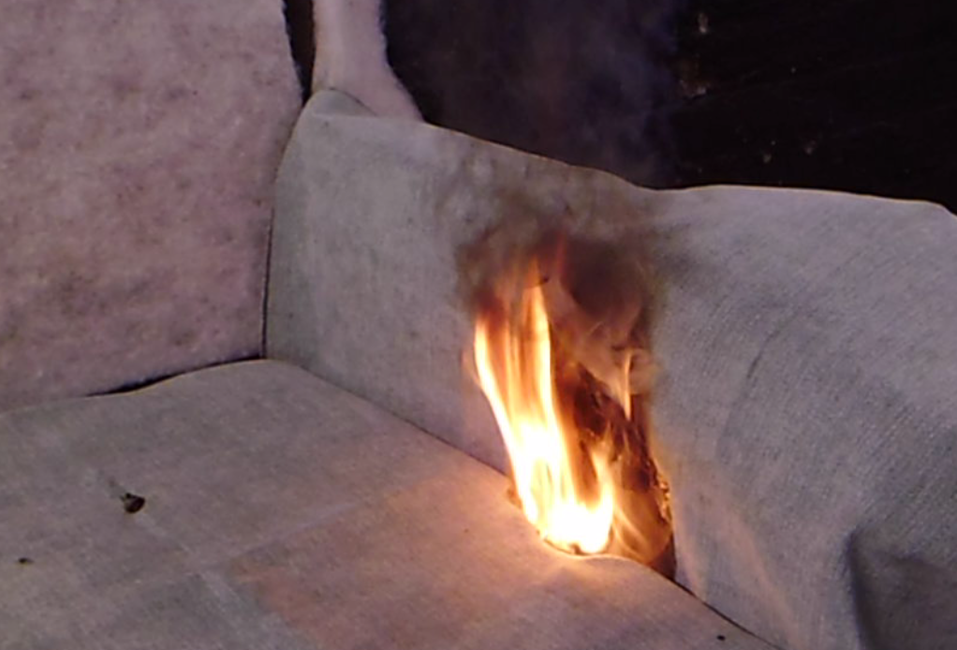

Below is a typical blended cover fabric (common in mid-range furniture). This is how it appears at the end of the current match test as performed to the requirements of the Regulations, i.e. it passes.

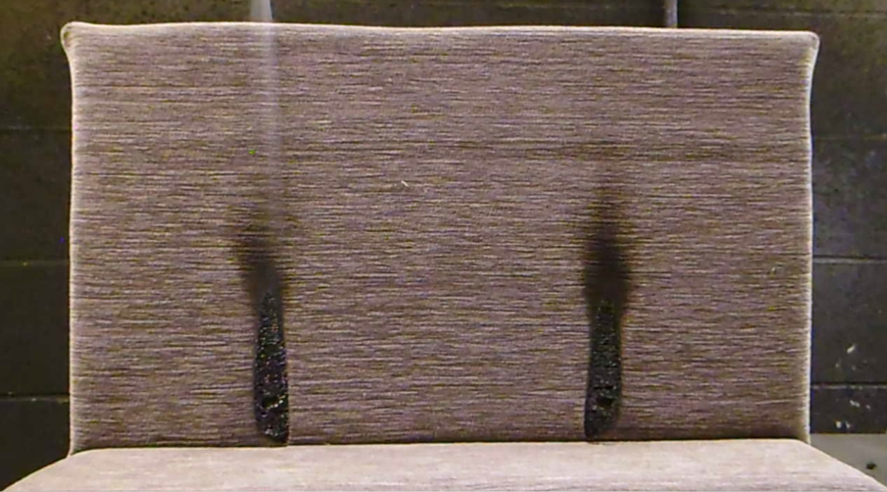

Below is the same material tested to the new test requirements: it fails. This is also how the material would be arranged in the actual finished product, i.e. with a fibre wrap layer between the cover and the filling material.

